|  |
| --- |
| Name: Karagoda Jayawardhana |
| Student Reference Number: 10898790 |



|  |  |  |
| --- | --- | --- |
| Module Code: PUSL2023 | Module Name: Mobile App Development | |
| Coursework Title: Project Proposal Submission. | | |
| Deadline Date: 19 February 2024 | | Member of staff responsible for coursework:  Mr. Diluka Wijesinghe |
| Program: CS | | |
| Please note that University Academic Regulations are available under Rules and Regulations on the University website [www.plymouth.ac.uk/studenthandbook](http://www.plymouth.ac.uk/studenthandbook). | | |
| Group work: please list all names of all participants formally associated with this work and state whether the work was undertaken alone or as part of a team. Please note you may be required to identify individual responsibility for component parts.  ***We confirm that we have read and understood the Plymouth University regulations relating to Assessment Offences and that we are aware of the possible penalties for any breach of these regulations. We confirm that this is the independent work of the group.***  Signed on behalf of the group: | | |
| Individual assignment: ***I confirm that I have read and understood the Plymouth University regulations relating to Assessment Offences and that I am aware of the possible penalties for any breach of these regulations. I confirm that this is my own independent work.***  Signed : | | |
| Use of translation software: failure to declare that translation software or a similar writing aid has been used will be treated as an assessment offence.  I *have used/not used translation software.  If used, please state name of software………………………………………………………………… | | |
| **Overall mark _____% Assessors Initials ______ Date_________** | | |

 

NSBM Green University

Faculty of Computing

PUSL 2023 – Mobile Application Development

Group Project Proposal – Group 83

|  |  |  |
| --- | --- | --- |
|  | Group Number | 83 |
|  | Student ID | Name |
| 1 | 10898790 | Karagoda Jayawardhana. |
| 2 | 10898781 | Buthsara Hirimuthugoda. |
| 3 | 10899406 | Ashini Gunawardhana. |
| 4 | 10898757 | Dissanayake Dissanayake. |
| 5 | 10898946 | Monasha T Wijerathne |
| 6 | 10898944 | Gamage Wijayasekara |

Table of Contents

Introduction 4

Problem Definition 4

Scope of the Project. 5

01.Overview: 5

02. Features: 5

•User Registration/Login: 5

•Event Creation: 5

•Participant Invitations: 5

•Calendar Integration: 6

•Voting Mechanism: 6

•Real-time Updates: 6

03. User Roles: 6

Organizer 6

Participants 6

04. Event Dashboard: 6

05. Notifications: 6

06. Security: 6

07. Scalability: 6

08. Timeline: 6

09. Budget: 6

10. Marketing and Launch: 6

Objectives 7

01. Scheduling Efficiency 7

02. User Flexibility 7

03. Automated Reminders 7

04. Time Zone Management: 7

05. Collaborative Decision-Making: 7

06. Integration with Calendars: 7

07. Customization Options: 7

08. Participant Availability Tracking: 7

09. Feedback Mechanism: 7

10. Security and Privacy: 8

Features of Application 8

01. Registration. 8

02. Group Creation. **Error! Bookmark not defined.**

02. Event Creation. 8

03.Presenting votes clearly. 8

04. Selection. 8

05. Timely Notification. 8

06. The versatility of voting. **Error! Bookmark not defined.**

07. Calendar Integration. 8

08. Participant Availability Polls. 8

09. Customizable Invitations 8

10. Real-time Updates **Error! Bookmark not defined.**

Diagrams. 9

Gantt Chart 10

References List 10

# Introduction.

There are many challenges that event planners in organizations must face when fixing a date and time for an event in their organization. Therefore, our team decided to create a modern mobile application that any event planner can easily reach, obtaining many advantages over event planning.

Our team also has considered the advantages of having a mobile application that can easily fix a date and time for any event in any organization. There is time efficiency, reduced conflicts, flexibility, data security, enhanced productivity etc.

The leader of the organization and all its members can connect with this mobile application. They can get together and decide the perfect date and time for their event too.

All parties involved in any changes in dates or times through real-time updates and notifications. By doing this, the organization's communication is improved, and everyone is aware of the timetables for the events.

The days of complicated spreadsheets and never-ending email conversations are long gone. All your organizational events may be easily scheduled, and rescheduled, and have their dates and hours synchronized with our app. Users can input preferences, limits, and availability using the user-friendly interface, which streamlines the decision-making process and helps to eliminate potential conflicts.

The app's clever algorithm suggests ideal dates and times by considering several variables, including participant and venue availability as well as time zone variations.

This increases attendance and reduces the possibility of scheduling problems, guaranteeing success and a high turnout at your events. Collaboration is at the core of our app, with real-time updates and notifications keeping all stakeholders informed. Whether you're planning a team meeting, a training session, or a company-wide conference, our Date and Time Fixing App empowers you to take control of your schedule effortlessly. This is the ultimate solution for seamless event management within your organization.

Our mobile application is made to the seamless and effective operation of your events. With our Date and Time Fixing App, bid logistical headaches a fond farewell and hello to efficiency. Take your corporate events to new heights by making sure that every detail is well thought out and carried out. Welcome to the future of event management with our dependable, creative, and easy-to-use solution.

# Problem Definition

Organizational event planners frequently struggle with the complex problem of scheduling, which emphasizes the necessity of an all-inclusive date and time fixing software. The current environment is characterized by manual procedures, inefficiencies, and the inherent difficulty of juggling conflicting timetables.

First, there is insufficient central coordination because of the widespread use of various communication channels, such as emails and messaging applications. Due to the decentralized approach's confusion-causing nature, stakeholders find it challenging to reach an agreement on appropriate dates and times as they sort through a maze of messages, attachments, and contradicting information.

Second, it takes a lot of time to schedule an event using the traditional ways. Planning is slowed down by endless email exchanges, spreadsheets, and meetings that take up important resources. This reduces productivity and increases the chance of errors because there are so many channels of communication and manual data entry that information may be missed.

Additionally, the difficulty is made worse by the fact that modern organizations are worldwide in scope. Working with participants who are in various time zones introduces another level of complication, which frequently results in scheduling errors and mismatches that have a detrimental effect on participation and teamwork.

Moreover, a major obstacle is the inability to adjust to changing timetables. It is inevitable that last-minute modifications may occur in the fast-paced business world of today. It is difficult to effectively accommodate changes in the absence of a responsive and agile system, which could lead to disruptions and a reduction in the overall efficacy of the event.

Finally, security issues are a major problem. The secrecy of critical event details may be jeopardized by using traditional communication channels. Organizations are placing a high priority on data security, and an insufficiently secured system increases the danger of unwanted access and jeopardizes the planning process's integrity.

The development of a strong Date and Time Fixing App is required to address these issues and open the door to seamless, secure, and effective organizational event planning. The core cause of the issue is the fragmented, time-consuming, and insecure nature of current event scheduling processes.

# Scope of the Project.

## 01.Overview:

Develop a mobile application to assist an organization schedule and manage activities more effectively.

## 02. Features:

### •User Registration/Login:

Safe authentication procedures for both attendees and coordinators.

### •Event Creation:

Events can be created by organizers, who can provide the details, date, time, and venue.

### •Participant Invitations:

Participant invitation options include email and app notifications.

### •Calendar Integration:

Users' calendars are coordinated to prevent schedule conflicts.

### •Voting Mechanism:

On recommended dates and times for the event, participants can cast their votes.

### •Real-time Updates:

Notifications of event updates, voting outcomes, and decisions made instantly.

## 03. User Roles:

Organizer: Able to plan, coordinate, and complete event details.

Participants: Get information about the event, cast votes on recommended dates, and receive invitations.

## 04. Event Dashboard:

A summary of all the events that are coming up, along with important information.

Status of the vote and comments from participants.

## 05. Notifications:

Push alerts for updated information on the event, vote results, and new invitations.

## 06. Security:

Secure data encryption and user authentication.

## 07. Scalability:

Create the app with the ability to handle an increasing number of users and events in mind.

## 08. Timeline:

Develop a reasonable development schedule that considers every phase, from planning to launch.

## 09. Budget:

Calculate the expenses related to development, testing, and continuing upkeep.

## 10. Marketing and Launch:

Create a marketing plan inside the company for the app launch.

The mobile application will function as a full solution for effective date and time setting for organizational events by taking care of these components.

# Objectives

## 01. Scheduling Efficiency

Give users an easy-to-use interface to choose their preferred date and time for events so they can plan them effectively.

## 02. User Flexibility

Permit users to suggest different times and dates, considering a range of schedules and preferences.

## 03. Automated Reminders

To lower the possibility of missed engagements, use automated reminders to inform participants of impending activities.

## 04. Time Zone Management:

Include functions that allow for the smooth handling of time zone variations, guaranteeing precise scheduling for participants spread across many locations.

## 05. Collaborative Decision-Making:

Promote group consensus by allowing participants to observe and react to suggested dates. This will aid in collaborative decision-making.

## 06. Integration with Calendars:

To give users a centralized picture of their obligations, synchronize event details with widely used calendar software.

## 07. Customization Options:

Depending on the type of event, it provides organizers with the ability to select precise timeslots, durations, and reoccurring patterns.

## 08. Participant Availability Tracking:

Enable organizers to monitor participant availability in real-time with the help of technologies, which will help them make more educated scheduling decisions.

## 09. Feedback Mechanism:

To enable ongoing enhancement of event preparation, develop a feedback mechanism and will gather participant feedback at the designated time and date.

## 10. Security and Privacy:

Make sure that date and time information is handled securely, that user privacy is respected, and that critical event details are shielded from unwanted access.

# Features of Application.

## 01. Registration.

The organization leader and all the members can register to system.

## 02.Create Groups.

Anyone can create a group (organization) with members.

## 03. Event Creation.

Organization leaders can easily create events. They can search and select groups and they can create an event with title description and possible dates.

## 04.Presenting votes clearly.

Everyone can vote, see others votes and people who votes.

## 05. Selection.

Members can take decisions and easily select perfect dates and times for the event.

## 06. Timely Notification.

When fix a suitable date and time for an event, send a notification to all the members in a group on time.

## 07. Calendar Integration.

Smooth calendar importation to import current commitments and prevent schedule conflicts.

## 08. Participant Availability Polls.

Let the organizers make availability surveys available to attendees so that preferences can be easily gathered, and the best time can be selected.

## 09. Customizable Invitations

Give event planners the option to customize invitations by adding information about the schedule, venue, and any unique requirements.

# Diagrams.

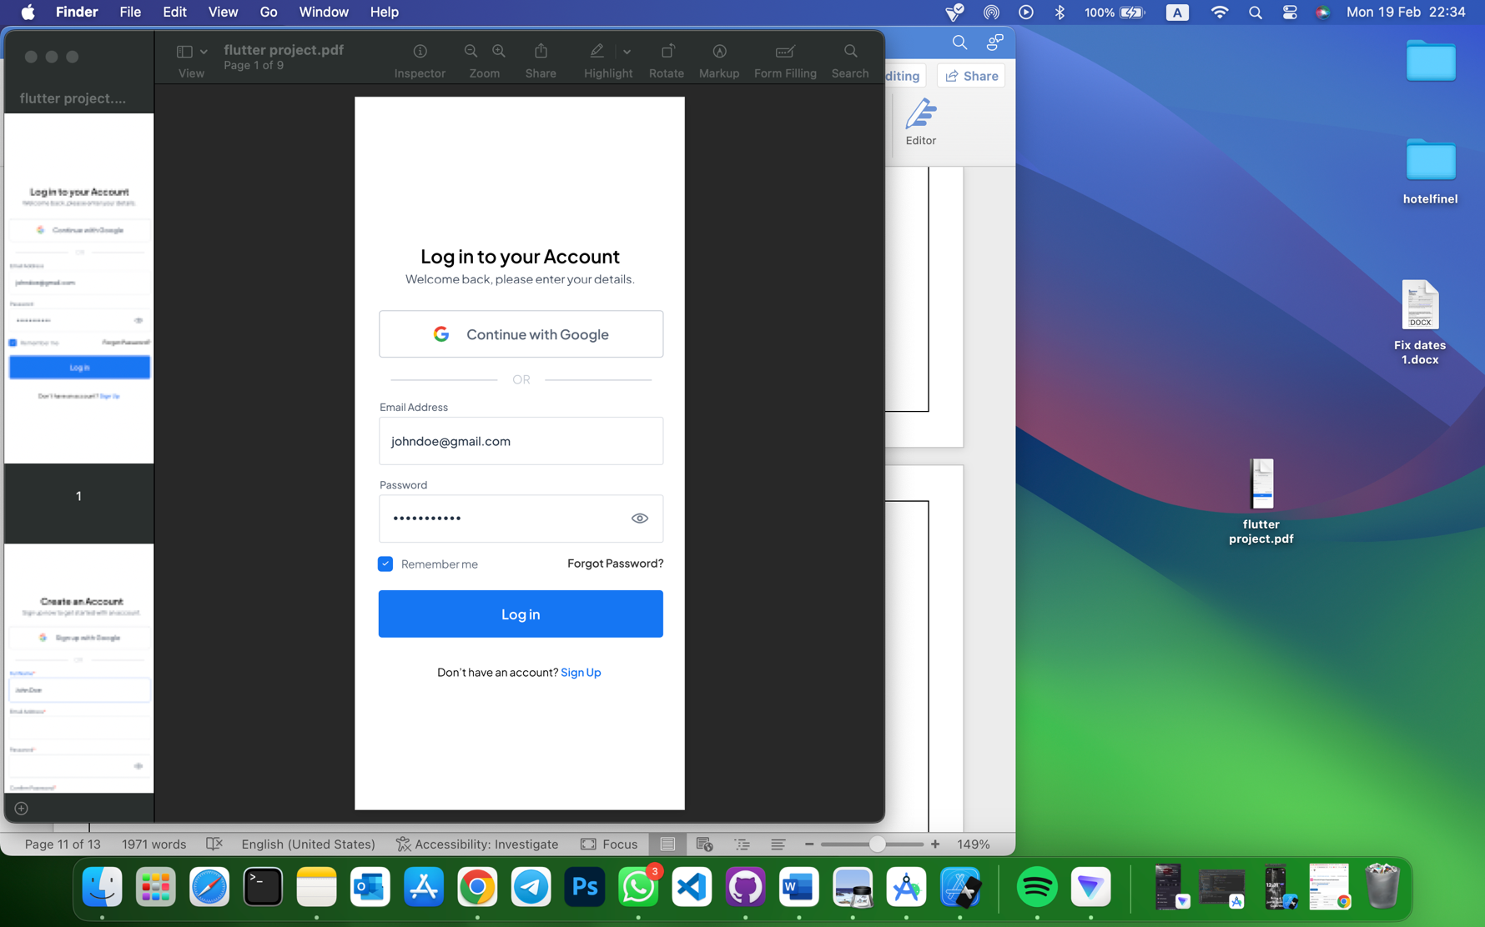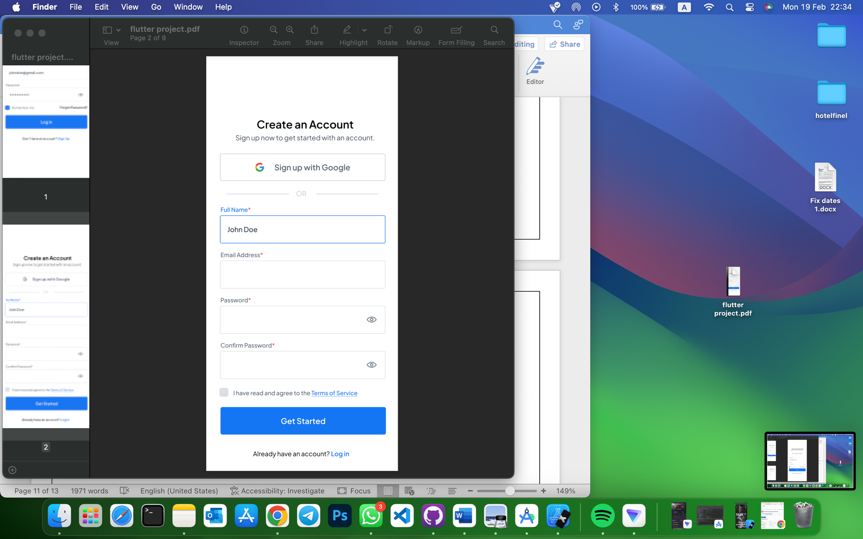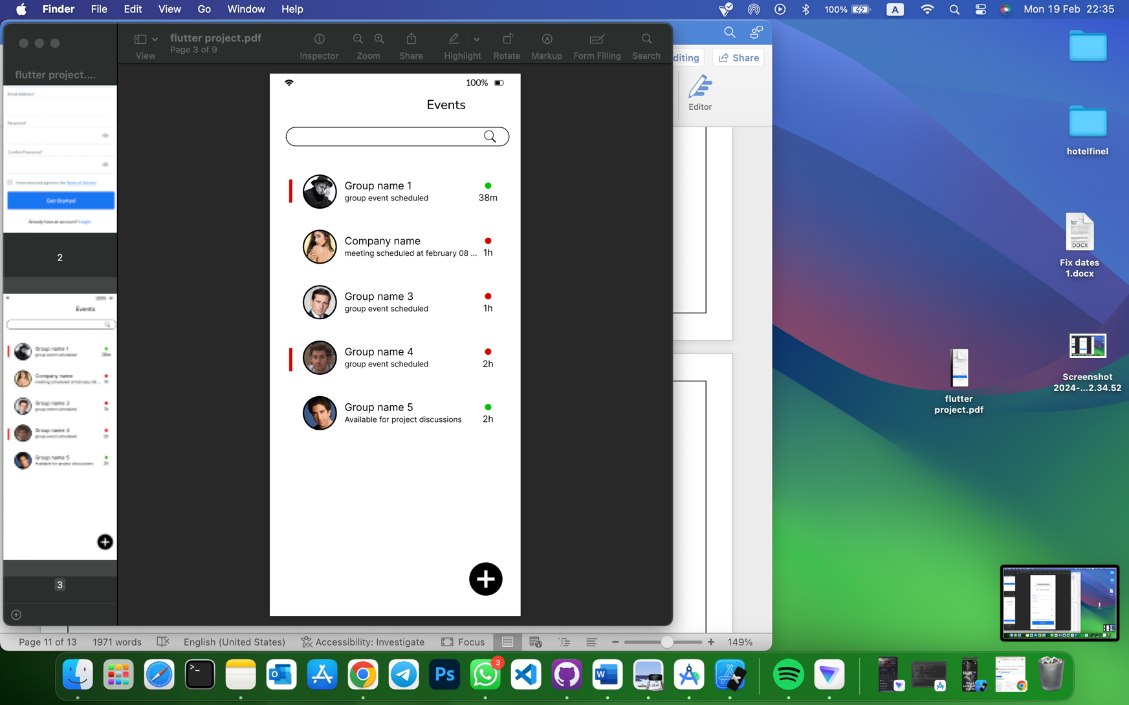

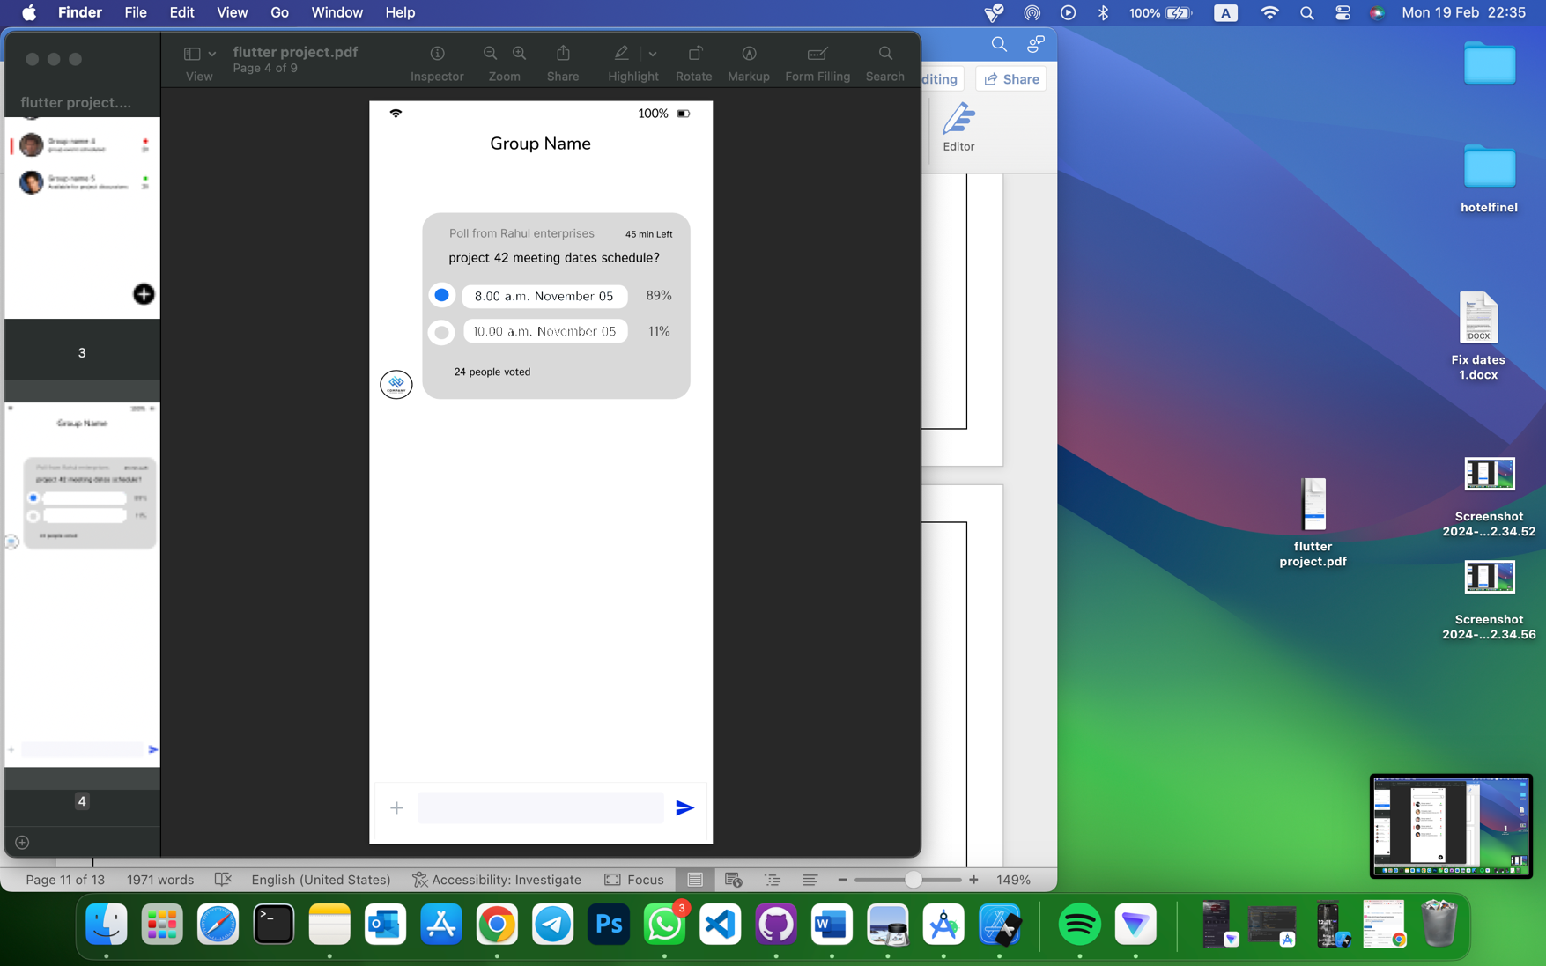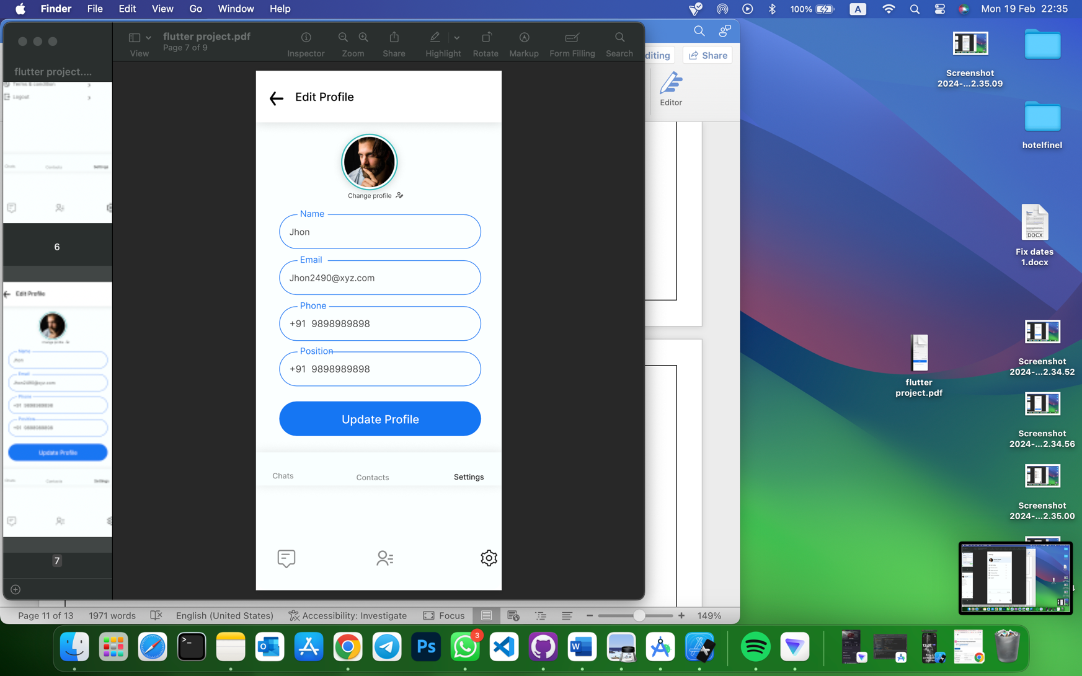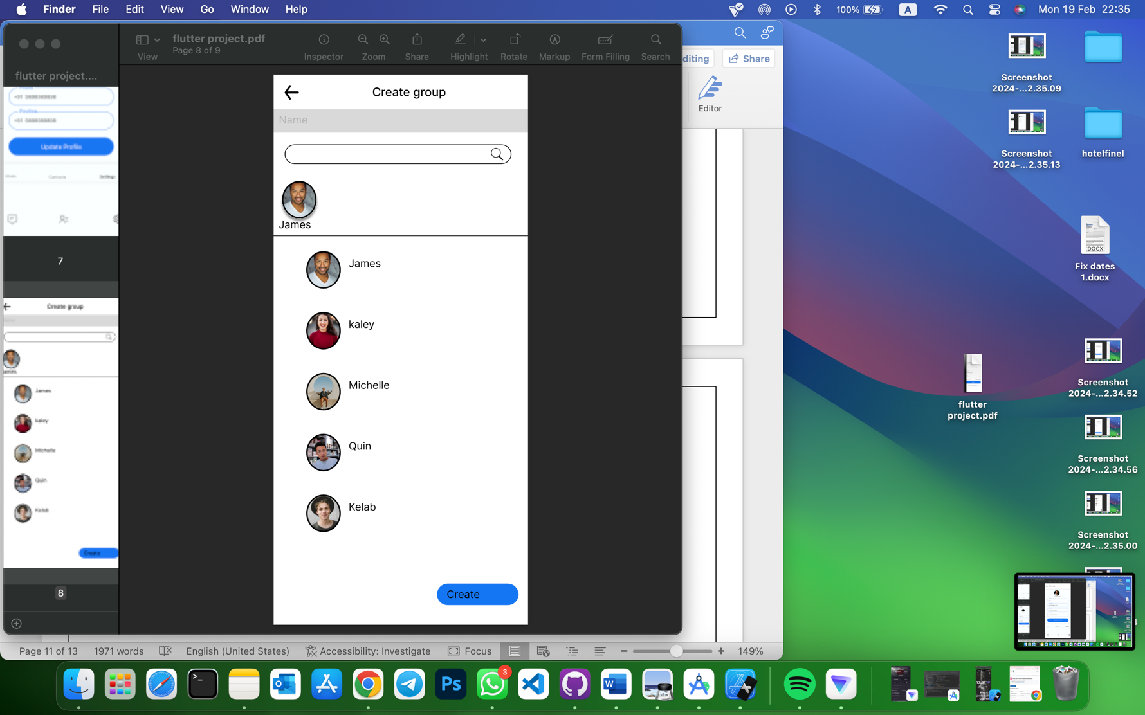

# Gantt Chart

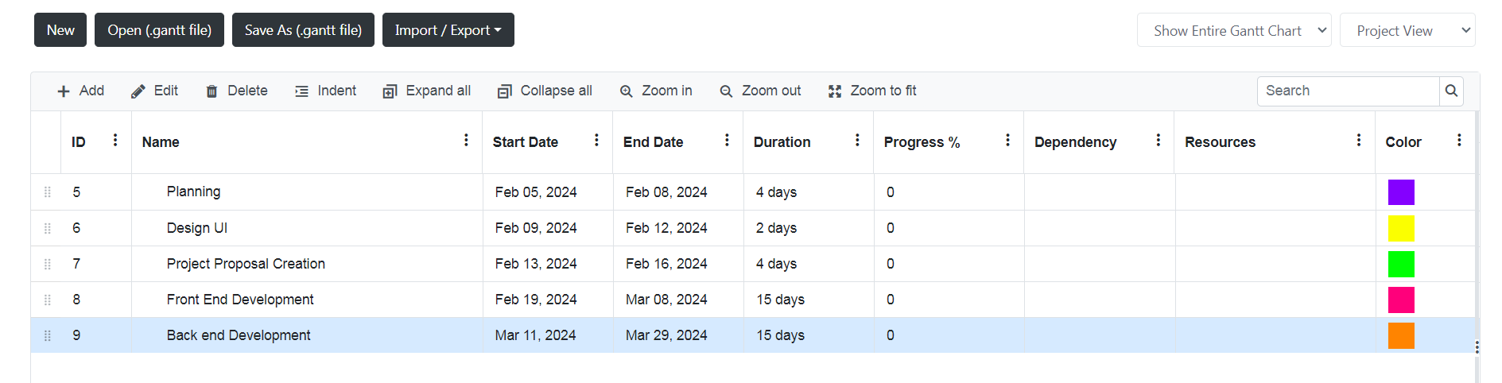

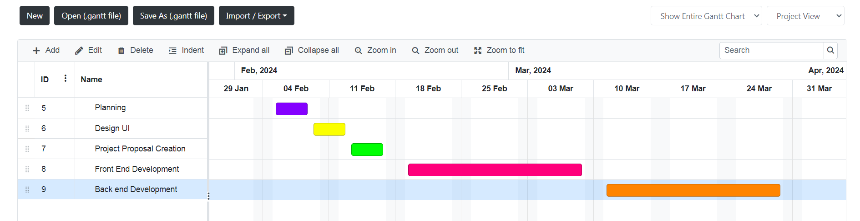

# References List

* Thomas, C. G., & Jayanthila Devi, A., (2021). A Study and Overview of the Mobile App

Development Industry. International Journal of Applied Engineering and Management

Letters (IJAEML), 5(1), 115-130. DOI: <http://doi.org/10.5281/zenodo.4966320>.

[Accessed 17 Feb. 2024].

* Saleh, H., Holmes, E., Bray, T. and Yusuf, S. (2016). Mobile Application Development: JavaScript Frameworks. [online] Google Books. Packt Publishing Ltd. Available at: <https://books.google.lk/books?id=aIdcDgAAQBAJ&printsec=frontcover&source=gbs_book_other_versions_r&redir_esc=y#v=onepage&q&f=false>

[Accessed 18 Feb. 2024].

* ResearchGate. (n.d.). (PDF) Mobile Apps Development: A Framework for Technology Decision Making. [online] Available at: https://www.researchgate.net/publication/236350960_Mobile_Apps_Development_A_Framework_for_Technology_Decision_Making

[Accessed 19 Feb. 2024].